Journal of Research and Applications in Mechanical Engineering
ISSN: 2229-2152 (Print); 2697-424x (Online)
(20xx) Vol. x, No. x, Paper No. JRAME xx-x-xxx
[DOI: 10.14456/jrame.xxxx.xx]

Research Article
Thermal Characteristics in a Heat Exchanger Tube Fitted with Zigzag-Winglet Perforated-Tapes
S. Suwannapan¹  S. Skullong^{2,}*  P. Promvonge³  ¹ Department of Mechanical Engineering, Faculty of Engineering, Rajamangala University of Technology Isan, Khonkaen Campus, 150 Srichan Road, Muang, Khonkaen, 40000, Thailand  ² Department of Mechanical Engineering, Faculty of Engineering at Si Racha, Kasetsart University Sriracha Campus, 199 M.6, Sukhumvit Rd., Sriracha, Chonburi 20230, Thailand  ³ Department of Mechanical Engineering,  Faculty of Engineering,  King Mongkut’s Institute of Technology Ladkrabang, Bangkok 10520, Thailand | ABSTRACT:  The paper presents an experimental investigation on enhanced heat transfer and pressure loss characteristics using zigzag-winglet perforated-tape inserts (ZW-PT) in a round tube having a uniform heat-fluxed wall for the turbulent air flow, Reynolds number (Re) from 4200 to 26,000. In the present work, the ZW-PT having the winglet attack angle of 45° were inserted into the test tube at two different winglet pitch ratios (P/D=PR=1 and 1.5) and four winglet-width or blockage ratios (b/D=BR=0.1, 0.15, 0.2 and 0.25). The experimental results of the heat transfer and pressure loss due to friction for propelling air through the tube are presented in terms of Nusselt number (Nu) and friction factor (f), respectively, reveal that the Nu and f increase with the increment of BR and Re but with the decreasing PR. The Nu for the inserted tube is in a range of 3.1–5.1 times above that for the plain tube while the f is around 12.5–53.6 times. In addition, the use of the ZW-PT with PR=1.0 leads to better thermal enhancement factor (TEF) than that with PR=1.5 around 3–5%.  Keywords: Thermal performance, zigzag-winglet, perforated-tape, Nusselt number, Reynolds number
1. Introduction
Many engineering and industrial techniques have been devised for enhancing the convective heat transfer rate from the heated wall surfaces such as solar air heater and heat exchanger systems. A heat exchanger as an equipment to facilitate the convective heat transfer of fluid inside the tubes is frequently utilized in many engineering and industrial applications for example, heat recovery process, cooling of turbine blades, air conditioning and refrigeration systems, solar water heater, chemical engineering process. To date, several studies have been focused on passive heat-transfer enhancement techniques. Passive enhancement techniques by tube inserts have been widely used for enhancing the heat transfer rate in a heat exchanger [1]. Insertion of vortex generator (VG) devices to generate the vortex flow such as wire coil [2], twisted tape [3], fin tape [4,5], baffle [6], winglet [7], in the flow passage to enhance the convective heat transfer rate is the most commonly known in many thermal systems.

For decades, the heat transfer enhancement by insertion of VG devices has been widely investigated both numerically and experimentally. The conjugate heat transfer and thermal stress in a circular tube with wire coiled inserted under a constant wall heat-flux was numerically investigated by Ozceyhan [8]. Chokphoemphun et al. [9] investigated numerically and experimentally the turbulent convection heat transfer in a circular tube inserted with winglet vortex generators (WVGs).

* Corresponding author: S. Skullong  E-mail address: sfengsps@src.ku.ac.th |  | 
They indicated that the thermal performance for the WVGs is found to be much higher than that for the wire coil and twisted tape. The heat transfer and pressure drop characteristics in a double pipe heat exchanger fitted with regularly-spaced twisted-tape elements at several space ratios were studied experimentally by Eiamsa-ard et al. [10]. Promvonge [11] conducted measurements using wire coils in conjunction with twisted tapes for heat transfer augmentation and reported that the combination of wire coil and twisted tape leads to a double increase in heat transfer over the use of wire coil/twisted tape alone. Influences of the straight full twist insert with different spacer distances on heat transfer characteristics were also studied by Krishna et al. [12]. Eiamsa-ard et al. [13] studied the effect of the short-length twisted tape on heat transfer, friction factor and thermal performance in a heat exchanger tube. Chiu and Jang [14] presented the numerical and experimental work on thermal–hydraulic characteristics of air flow inside a circular tube with five different tube inserts; longitudinal strip inserts both with/without holes and twisted-tape inserts with three different twist angles for different inlet velocity ranging from 3 to 18 m/s. Promvonge et al. [15] examined the heat transfer, friction loss and thermal performance in a round tube fitted with inclined horseshoe baffle inserts. They found that the horseshoe baffle at BR=0.1, PR=0.5 provides higher thermal performance than other baffles. A 3-D numerical simulation of swirling flow and convective heat transfer in a circular tube fitted with loose-fit twisted tapes were also reported by Eiamsa-ard et al. [16].

According to the literature, the heat transfer enhancement strongly depends on the baffle/winglet structure. Devices with more proper geometries give better thermal performance enhancement. In the present work, the novel 45º winglets with two different winglet pitch ratios (P/D=PR=1.0 and 1.5) and four winglet-width or blockage ratios (b/D=BR=0.1, 0.15, 0.2 and 0.25) are proposed. The experimental results using air as the test fluid for the 45º ZW-PT inserted tube are presented for turbulent flows in a Reynolds number range of 4200 to 26,000 in the current work.
2. Experimental Setup
A schematic diagram of the experimental apparatus is presented in Fig. 1. In the apparatus setting above, inlet air at 25 ºC from a 1.5 kW blower was directed through an orifice flow-meter and passed to the heat transfer test section. The airflow rate was measured by the orifice flow-meter calibrated by using a hot-wire anemometer. The volumetric airflow rate from the blower was adjusted by varying the motor speed of the blower through an inverter. The copper test tube has a length of 3000 mm long, included the test section (L) of 1200 mm with 50.2 mm inner diameter (D) and 54.3 mm outer diameter (D_{o}) as depicted in Fig. 2. The tube was heated by continually winding flexible electrical wire to provide a uniform heat-flux condition. The outer surface of the test tube was well insulated to minimize convective heat loss to the surroundings. The inlet and outlet temperatures (T_{i} and T_{o}) of the bulk air were measured at certain points with a multi-channel temperature measurement unit in conjunction with the RTD PT 100 type temperature sensors while the surface temperatures (T_{w}) were measured by 16 T-type thermocouples located equally on each of the top and side walls along the test section. Two static pressure taps coupled with a digital manometer were used to measure pressure drops across the test section. The Reynolds number of the bulk air was varied from 4200 to 26,000.

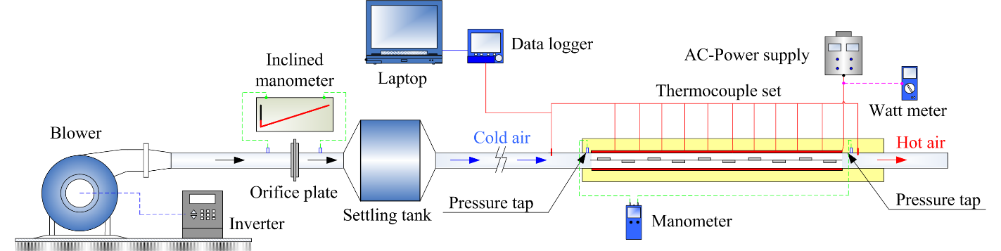
Fig. 1. Schematic diagram of the experimental setup.

Figure 2 displays the ZW-PT arrangements used in the present work. Each winglet was made of a 0.3 mm thick (t) aluminum strip with 50 mm long (l). The perforated-tape made of aluminum sheet were 1200 mm long and 0.5 mm thick (e). To obtain a perforated-tape, several holes were punched along the central line of the straight tape with a single diameter (d) of 10 mm while the pitch distance between holes drilled was equal to a half diameter of the tube (0.5D). At the tape edges, half-holes with similar diameter and pitch of the center holes were drilled along both edges. The winglets were attached repeatedly to the perforated-tape using hot glue on both sides of the tape in zigzag-arrangement as seen in Fig. 2. The 45º ZW-PT with various geometries including two different winglet pitch ratios and four winglet-width or blockage ratios were inserted into the tube by wall-attached position. The parameter ranges of the investigation were given in Table 1.

(a) test tube with 45º ZW-PT insert (b) photograph of tube insert
Fig. 2. The ZW-PT arrangements used in the present work.

Table 1: Ranges of parameters in the investigation.
Working fluid  Reynolds number | Air  4200 to 26,000
b/D=BR | 0.1, 0.15, 0.2, 0.25
P/D=PR | 1.0 and 1.5
Tape thickness,  | 0.5 mm
Tape length, L | 1200 mm
Winglet thickness, t | 0.3 mm
Winglet length, l | 50 mm
3. Data Processing
The data reduction for flow condition (Reynolds number, Re), heat transfer rate (Nusselt number, Nu), pressure drop (friction factor, f), and thermal enhancement factor (at the same pumping power), are described in this section. The Re based on the tube diameter is given by

(1)

The f computed by pressure loss across the test tube length is written as

(2)

in which U is the mean air velocity in test tube.

In the experiment, air flowed through the test tube having a uniform heat-fluxed wall. The steady state of the heat transfer rate is assumed to be equal to the heat loss from the test section which can be expressed as:

(3)
where
(4)

The convection heat transfer from test section can be written by

(5)

in which

(6)

and

(7)

where T_{w} is local wall temperature along the test tube. The average wall temperature is calculated from 16 points of surface temperatures lined equally between the inlet and the exit of test tube. The average heat transfer coefficient (h) and mean Nusselt number (Nu) are estimated as follows:

(8)

The heat transfer is calculated from the Nu which can be obtained by

(9)

All of thermo-physical properties of air are determined at the overall bulk air temperature (T_{b}) from Eq. (6).
The thermal enhancement factor (TEF) is given by

(10)

where h_{p} and h_{s} are heat transfer coefficients for plain tube and the inserted tube, respectively.
4. Results and Discussion
4.1 Verification of plain tube
The comparison of the experimental heat transfer (Nu) and friction loss (f) results of a plain tube in the present work and those obtained from the standard correlations [17] of Dittus-Boelter and Blasius, as given in Eqs. (11) and (12), is depicted in Fig. 3. In the figure, measured data are in good agreement with correlation’s data. The average deviation of the measured is about 6% for both Nu and f.
Dittus-Boelter correlation:

(11)

Blasius correlation:

(12)

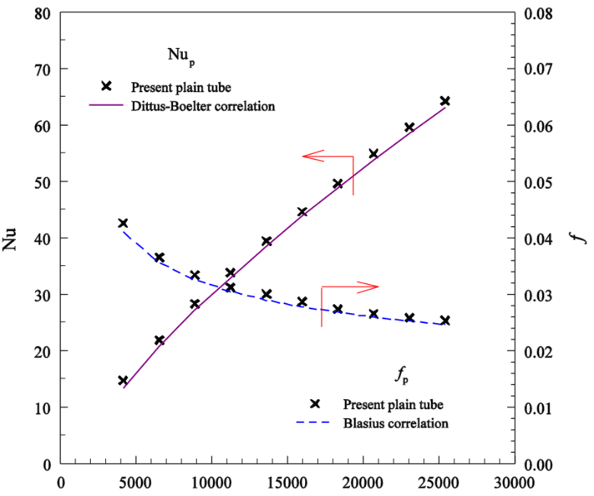
Fig. 3. Verification of Nu and f for plain tube.

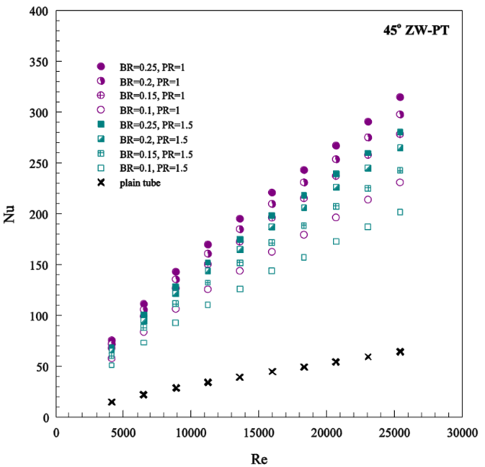 | 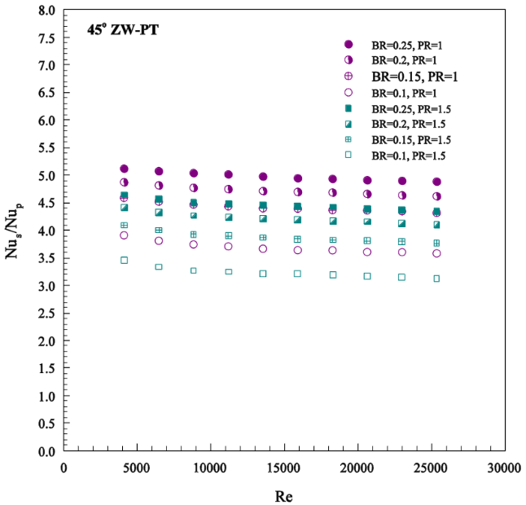
(a) Nu | (b) Nu_{s}/Nu_{p}
Fig. 4. Variation of Nu and Nu_{s}/Nu_{p} with Re for ZW-PT insert.

4.2 Effect of ZW-PT on heat transfer
Figure 4a and b presents the relationship between Nusselt number (Nu) and Nusselt number ratio (Nu_{s}/Nu_{p}) with Re for using the ZW-PT with different BR and PR values. As compared to the results of the plain tube, the heat transfer was considerably enhanced with the presence of ZW-PT. This is due to the interruption of the flow by the turbulator results in the destruction of thermal boundary layer near the tube wall. Under similar conditions, the Nu increases with the rise of Re and BR but with the decreasing PR. The ratio of augmented Nu of inserted tube to Nu of plain tube, Nu_{s}/Nu_{p} plotted against the Re is depicted in Fig. 4b. In the figure, the Nu_{s}/Nu_{p} tends to decrease slightly with the rise of Re for all cases. It is noted that the BR = 0.25 provides the highest Nu_{s}/Nu_{p}. This is caused by higher flow blockage of BR = 0.25 interrupting the flow leading to stronger vortex flow strength and, thus, more efficient heat transfer between the working fluid and the heated wall surface. The average increases in Nu_{s}/Nu_{p} for using the 45° ZW-PT with BR = 0.1, 0.15, 0.2 and 0.25 are about 369%, 441%, 472% and 497%; and 324%, 388%, 422 and 446% for PR = 1.0 and 1.5.

4.3 Effect of ZW-PT on friction factor
Figure 5a and b depicts the variation of friction factor (f) and friction factor ratio (f_{s}/f_{p}) with Re for various ZW-PT inserts, respectively. It is clearly observed in Fig. 5a that the ZW-PT provides a substantial increase in f above the plain tube, due to the dissipation of dynamic pressure of the fluid due to higher surface area and the reverse/swirl flow. The mean increase in the f of the ZW-PT is in a range of 15-46 times over the plain tube. The ZW-PT at PR=1.0 gives much higher f than that at PR=1.5 and the f increases with the increment of BR. Fig. 5b presents the variation of f_{s}/f_{p} with Re for various BR and PR values. In the figure, the f_{s}/f_{p} tends to increase with the rise of Re for all insert cases. The maximum f_{s}/f_{p} of about 53.6 times is seen for the ZW-PT at BR = 0.25 and PR = 1.0. The mean f_{s}/f_{p} for the ZW-PT at PR = 1.0 is seen to be higher than the one at PR = 1.5 around 18.4-24.3%.

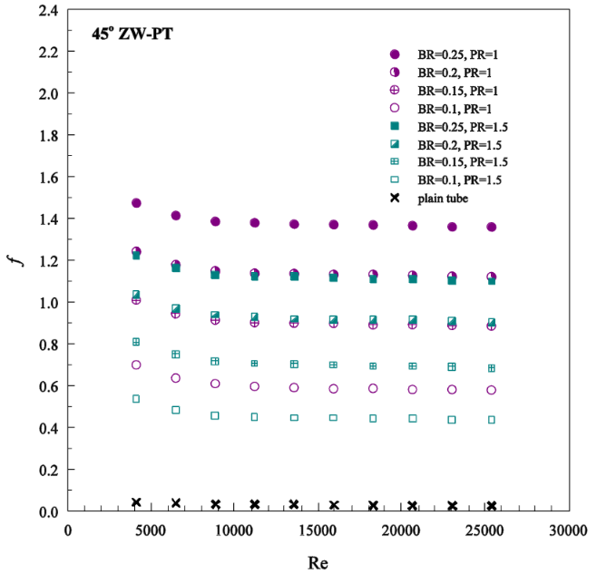 | 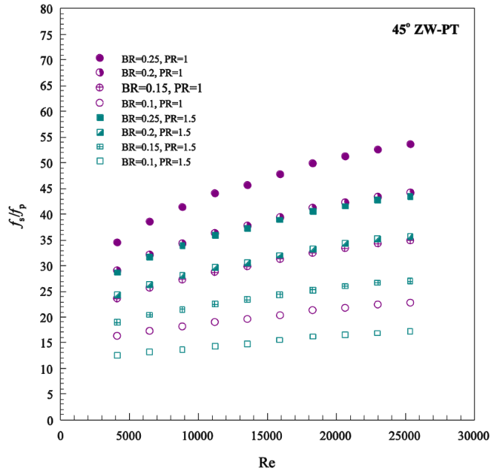
(a) f | (b) f_{s}/f_{p}
Fig. 5. Variation of f and f_{s}/f_{p} with Re for ZW-PT insert.

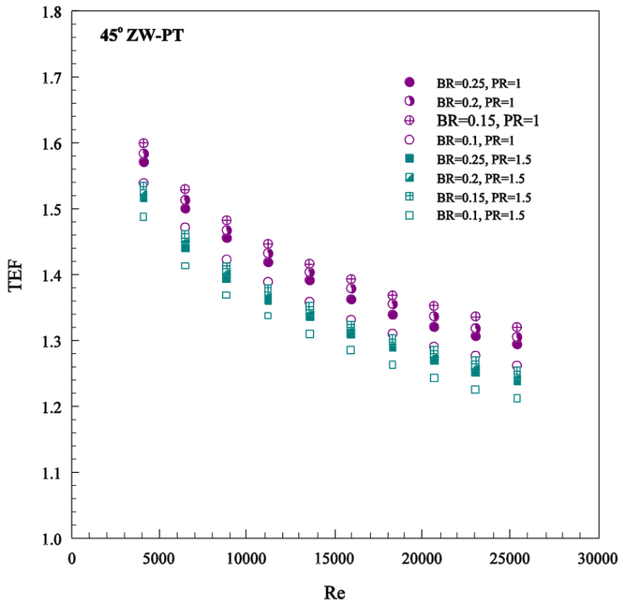
Fig. 6. Variation of TEF with Re.

4.4 Effect of ZW-PT on thermal performance
The variation of the thermal enhancement factor (TEF) with Re values for all inserts is shown in Fig. 6. The TEF is achieved by simultaneously evaluating the Nu and f in the enhanced tube and plain tube under constant pumping/blowing power conditions taken into account by using Eq. (10). In the figure, the TEF shows the downtrend with the increase of Re for all inserts. The maximum TEF is between 1.32-1.6 for BR = 0.15 and PR = 1.0 while the minimum one is between 1.2-1.49 for BR = 0.1 and PR = 1.5, depending on Re values. The highest TEF of 1.59 is found for the ZW-PT at BR = 0.15 and PR = 1.0 at the lowest Re.
5. Conclusion
The thermal performance in a round tube inserted with 45° ZW-PT at two PR and four BR values has been investigated experimentally for the turbulent regime, Re = 4200-26,000 under a uniform wall heat-flux condition. The Nu increases whereas f decreases with the increase in Re. The use of the 45° ZW-PT leads to considerable heat transfer enhancement over the plain tube at about 324-497% depending on the Re, PR and BR values. The f of the ZW-PT is found to be 15-46 times above that of the plain tube. The maximum TEF of around 1.6 is found for the ZW-PT with BR = 0.15, PR = 1.0 at the lowest Re.
Nomenclature
A heat transfer surface area, m²
b winglet height, m
BR winglet blockage ratio (b/D)
C_{p,a} specific heat of fluid, J/kg-K
D inner diameter of test tube, m
D_{o} outer diameter of test tube, m
d hole diameter of perforated tape, m
e thickness of tape, m
f friction factor
h convective heat transfer coefficient, W/m²-K
k thermal conductivity of fluid, W/m-K
L length of test section, m
l winglet length, m
mass flow rate, kg/s
Nu Nusselt number
P axial pitch spacing of winglet, m
PR pitch ratio (P/D)
ΔP pressure drop, Pa
Pr Prandtl number
Q heat transfer rate, W
Re Reynolds number
mean temperature, K
T temperature, K
TEF thermal enhancement factor
t thickness of winglet, m
U mean air velocity, m/s
W tape width, m
ZW-PT zigzag-winglet perforated-tape
α attack angle of winglet, degree
ρ fluid density, kg/m³
ν kinematic viscosity, m²/s
Subscripts
a air
conv convection
i inlet
o outlet
p plain tube
pp pumping power
s inserted tube
w wall
References
The References part should follow the Vancouver style, and only in English. The relevant works must be cited and listed as references at the end of the manuscript, in order of citation. They should be chronologically referred in the text by Arabic numerals enclosed in square brackets, e.g. [1], [1, 2], [1-3]. The reference list should be set in the same type face as the body of the text. Some example of the references to journals, proceedings, technical reports, books and web-based articles are illustrated as follows:

Article in Journals

Authors. Title of article. Title of Journal. Year;Vol.(No.):Page.
[1] Chinvorarat S, Vallikul P. A novel retractable landing gear of a light amphibious airplane design, synthesis, analysis, and implementation. Aircr Eng Aerosp Technol. 2021;93(10):1547-1558.

Proceedings/Conference

Authors. Title of article. Conference title; date of conference; place of conference. Place of publication: Publisher; Year. Page.
[1] Resendiz-Trejo J, Yu W, Li X. Support vector machine for nonlinear system online identification. 3rd International Conference on Electrical and Electronics Engineering; 2006 Sep 6-8; Veracruz, Mexico. USA: IEEE; 2006. p. 1-4.

Reports

Authors/Department/organizer. Title. Place of publication: Publisher; Year. Report no.
[1] Smith P, Golladay K. Payment for durable medical equipment billed during skilled nursing facility stays. Final report. Dallas: Office of Evaluation and Inspection; 1994. Report no.: HHSIGOEI69200860.

Book

Authors. Title of book. Edition. Place of publication: Publisher; Year.
[1] Vapnik V. The nature of statistical learning theory. NewYork: Springer-Verlag; 1995.
[2] Murray PR, Rosenthal KS, Kobayashi GS, Pfaller MA. Medical microbiology. 4th ed. St. Louis: Mosby; 2002.

Chapter in Books

Authors. Title of a chapter. In: editor. Title of book. Edition. Place of publication: Publisher; Year. Page.
[1] Meltzer PS, Kallioniemi A, Trent JM. Chromosome alterations in human solid tumors. In: Vogelstein B, Kinzler KW, editors. The genetic basis of human cancer. New York: McGraw-Hill; 2002. p. 93-113.

Thesis/Dissertation

Authors. Title [thesis/dissertation]. Place of publication: University; Year.
[1] Borkowski MM. Infant sleep and feeding: a telephone survey of Hispanic Americans [dissertation]. Mount Pleasant (MI): Central Michigan University; 2002.

Web-based articles

Author/Departmant/Organizer. Title of webpage [Internet]. Place: Publisher; Year [cited date of cited]. Available form: URL.
[1] Spath PL, Mann MK. Life Cycle Assessment of a Natural Gas Combined-Cycle Power Generation System [Internet]. Colorado: National Renewable Energy Laboratory; 2002 [cited 2010 Apr 24]. Available form: https://www.doe.gov.

